CSA1708-ARTIFICIAL INTELLIGENCE
LAB EXPERIMENTS
Program 3 : Python Program for Water Jug Problem
Aim
To develop a Python program to solve the Water Jug Problem using Breadth-First Search (BFS) to measure a target volume of water using two jugs of specified capacities.
Algorithm
1. Define the capacities of the two jugs (Jug 1 with capacity X, Jug 2 with capacity Y) and the desired target quantity Z.
2. Represent the state as an ordered pair (x, y), where x denotes the volume of water currently in Jug 1 and y denotes the volume in Jug 2.
3. Initialize the starting state as (0, 0) and enqueue it into a BFS queue along with an empty action history.
4. Maintain a visited set initialized with (0, 0) to avoid exploring repeated states.
5. While the queue is not empty, dequeue the current state (x, y):
6. a. If either jug contains the target amount (x == Z or y == Z), return the sequence of operations leading to this state.
7. b. Generate all valid next states based on allowable production rules:
8. - Rule 1: Fill Jug 1 completely -> (X, y)
9. - Rule 2: Fill Jug 2 completely -> (x, Y)
10. - Rule 3: Empty Jug 1 -> (0, y)
11. - Rule 4: Empty Jug 2 -> (x, 0)
12. - Rule 5: Pour from Jug 1 to Jug 2 until Jug 2 is full or Jug 1 is empty.
13. - Rule 6: Pour from Jug 2 to Jug 1 until Jug 1 is full or Jug 2 is empty.
14. For each generated state that has not been visited, add it to the visited set and enqueue it with the updated path.
15. If the queue is exhausted without finding a solution, report that the target cannot be measured.

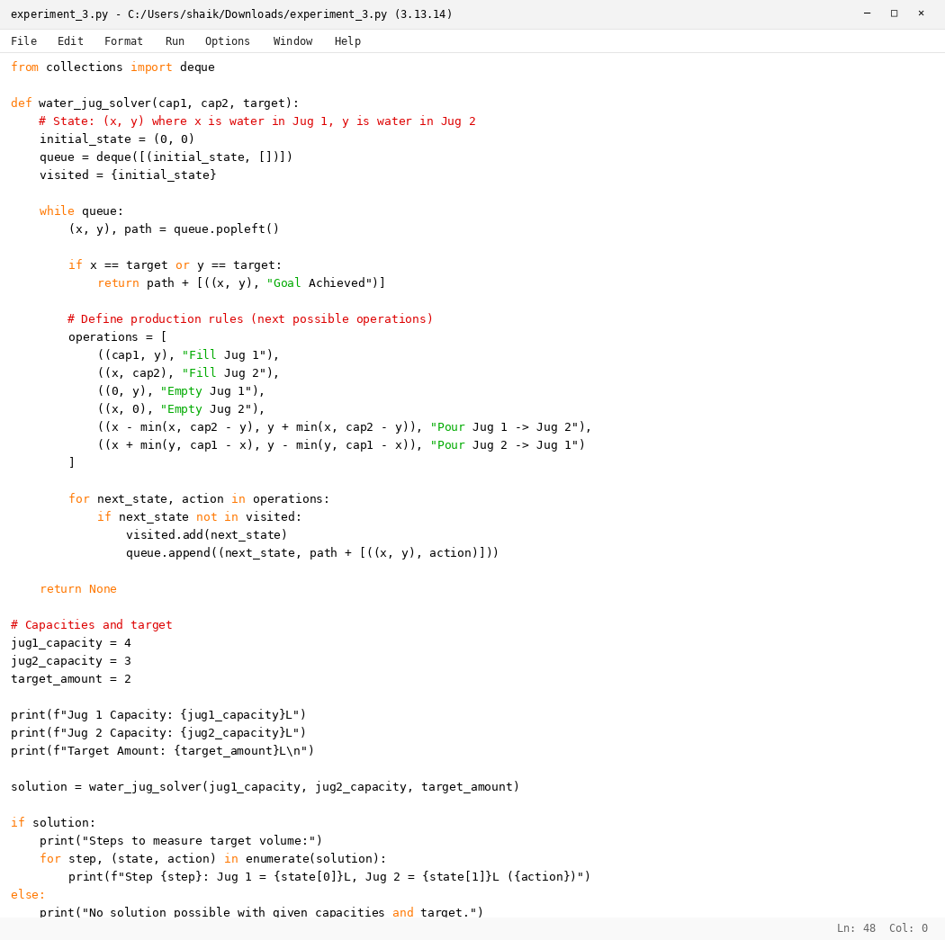

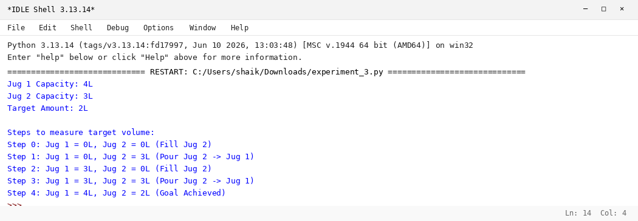

RESULT
Thus, the Water Jug Problem was solved successfully using Python.

